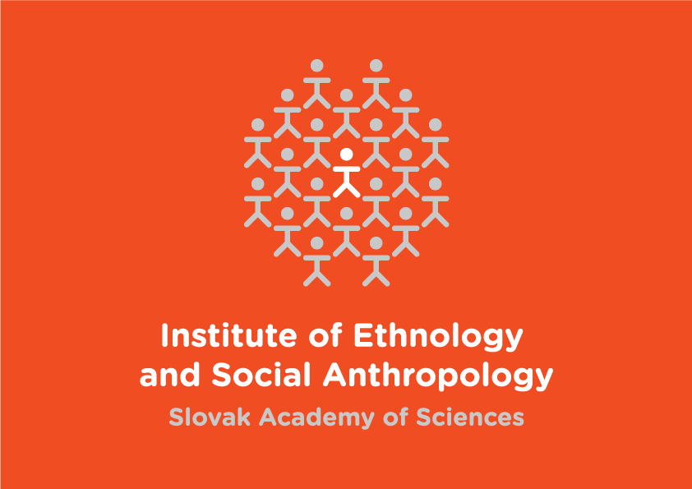
Pozvánka na Odborný seminár Ústavu etnológie a sociálnej antropológie SAV

Pozývame Vás na odborný seminár, na ktorom bude
Jonathan Larson,
Instructor of Anthropology, Grinnell College, USA

prezentovať zistenia z výskumu v prednáške s názvom

The Lives of Others: Surveillance, Discourse, and the Refashioning of Political Belonging in East Central Europe and the U.S.

Seminár bude v utorok 7. 5. 2019 o 14.00 hod. v podkroví budovy
spoločenskovedných ústavov SAV, Klemensova 19, Bratislava.

Ústav etnológie a sociálnej antropológie SAV,
Klemensova 19, 813 64 Bratislava
tel.: 02 /5296 4707 kl. 112, e-mail: tomas.hrustic@savba.sk; www.uet.sav.sk

A debate has been running for the past decade in a Euro-American public sphere about legitimate uses of surveillance technologies to maintain public security and facilitate consumer product development while respecting concerns over rights to privacy. While much of this surveillance has earned grudging acceptance as inherent to the infrastructure of a modern life, reception of its uses has varied. In this presentation I explore a pattern to how eavesdropping scandals of 2006 to 2014 were received in Hungary, Slovakia, the Czech Republic, and Poland. I argue that general public acceptance in the region of what I call “wild eavesdropping” has some basis in a post-socialist regime of truth that has valued hidden information. I outline some features in an anthropology of eavesdropping, and also explore what this public reception tells us about shifting ideologies of language in East Central Europe, and what these shifts have perhaps forewarned about attitudes toward the behavior of U.S. President Donald Trump.

